

**How to Guide: Storefront Admin, Catalogue Management & Order Processing.**

**Business Central**

**Dynamics 365**



**Section X: Description**

**TABLE OF CONTENTS**

1 Introduction 4

2 Get Started 4

2.1 Admin Login 4

2.2 Search 5

2.3 My Settings 5

2.4 Assisted Setup 6

3 Departments & Categories 7

3.1 Create a new Category 8

3.2 Promote a Category 10

4 List a Product 12

4.1 Create an Item 12

4.2 Special Pricing 13

4.3 Delist a product 14

4.4 Bulk Creation 14

5 Create a Customer 15

5.1 Default Payment Methods 16

6 Create an Ecommerce Login Account 17

6.1.1 Disable a Login Account 17

6.1.2 Password Reset 17

7 Order Processing 18

7.1 Send an Order Confirmation 19

7.2 Process an Order 19

7.3 Process a Payment 21

7.4 Process a Return 22

8 Content Management 24

8.1 Self Service 24

8.2 Static Content – basic CMS 25

9 Payment Service Provider Integration 27

9.1 Online Payments 27

9.2 PayGate 27

9.3 Netcash – Pay Now 27

10 Tips 28

10.1 Naming conventions and standards 28

10.2 Create a Ecommerce Test Account 28

10.3 Set up E-mail notifications 29

10.4 Add a Click & Collect Location 30

10.5 Add a Customer Delivery Address 31

10.6 Add a Shipping Provider & Charge 32

10.7 Setup 33

10.8 Cart & Order Statuses 34

11 System Requirements 35

12 Conclusion 35

# Introduction

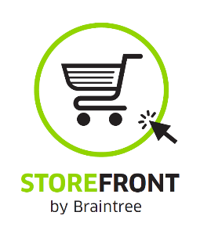Welcome to Storefront, powered by Microsoft Dynamics 365 Business Central!

Storefront is a rapid start ecommerce business management platform. Set up your Products, Prices & Content in no time. Start selling online fast.

The following document outlines how to set up and use Storefront & Storefront Admin.

# Get Started

## Admin Login

Sign into Storefront Admin at <https://businesscentral.dynamics.com/> with your on Microsoft account:

[my-store@onmicrosoft.com](mailto:my-store@onmicrosoft.com)

Once signed in, your Role Center landing page opens with information and tasks related to your user profile role.



From here you can navigate to any task by using the Search function:

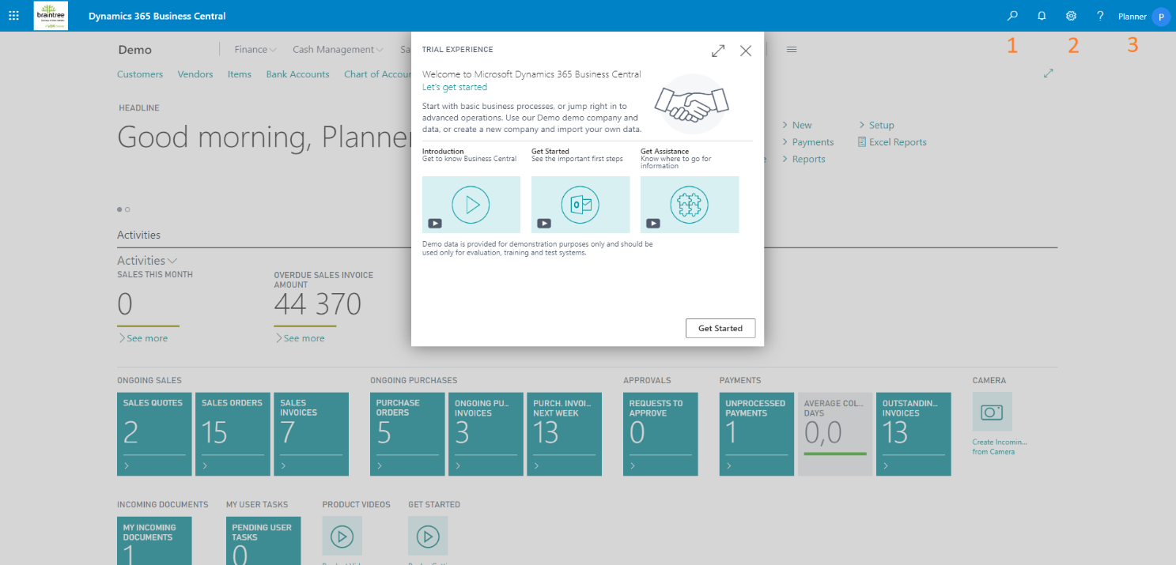

1. Search
2. My Settings
3. Microsoft Account

## Search

 Search for information & tasks such as Items, Customers, Sales Orders & Sales Invoices. Click to open.

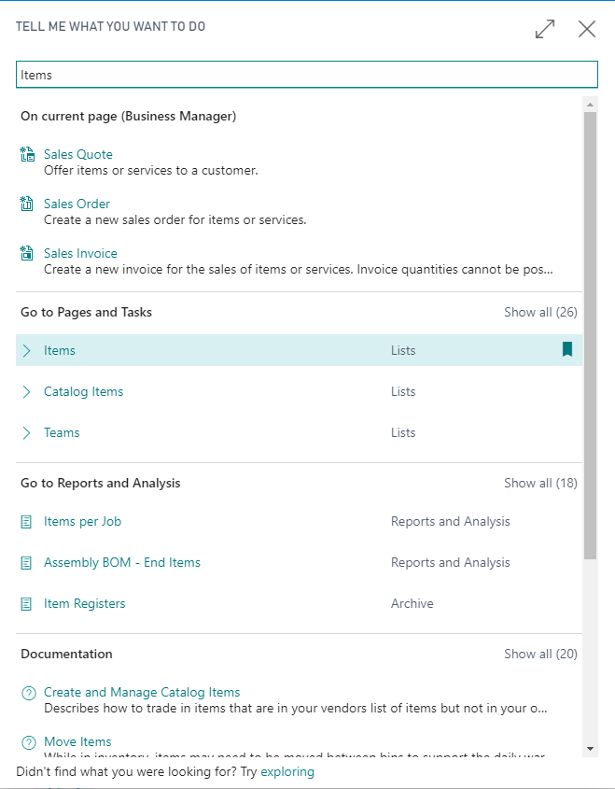

## My Settings

Change your user profile’s Role. Start by using the Business Manager or Sales Order Processing Role.

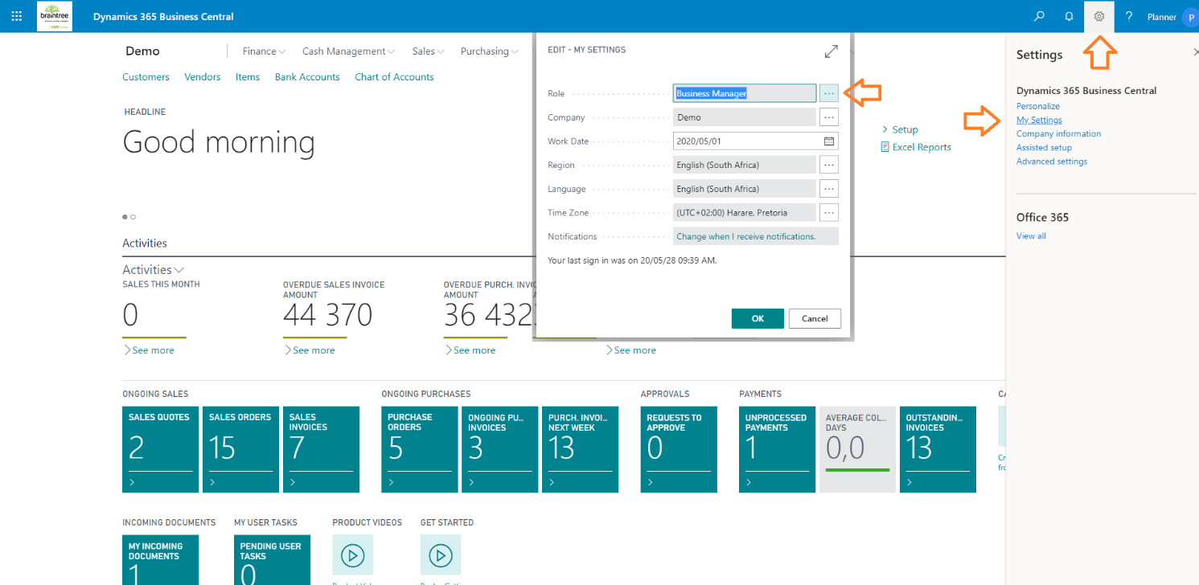

## Assisted Setup

Assumes Business Manager Role

Set up your company information, including address, contact info & logos: Set up my company:

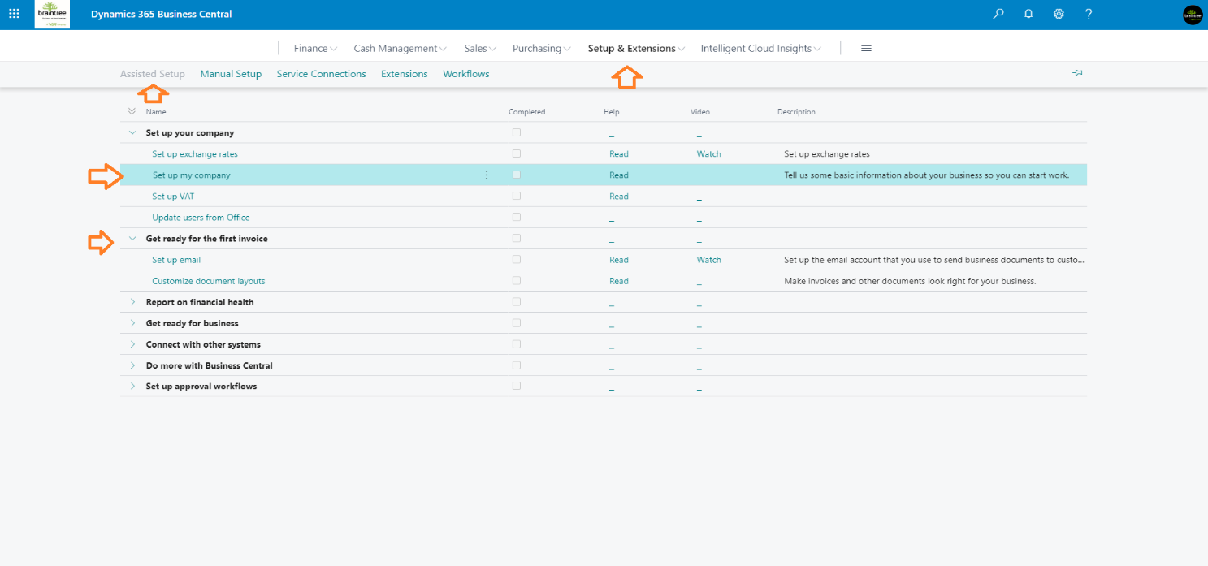

Also consider setting up email and tailoring document layout under Get ready for the first invoice. You can always come back to this step.

# Departments & Categories

Assumes Business Manager Role

Create Item Categories to represent your ecommerce categories or departments. Multi-level categorisation is supported, parent / child classifications. Categories are allocated to products. Once categorised, products are listed under categories.

Ecommerce categories:

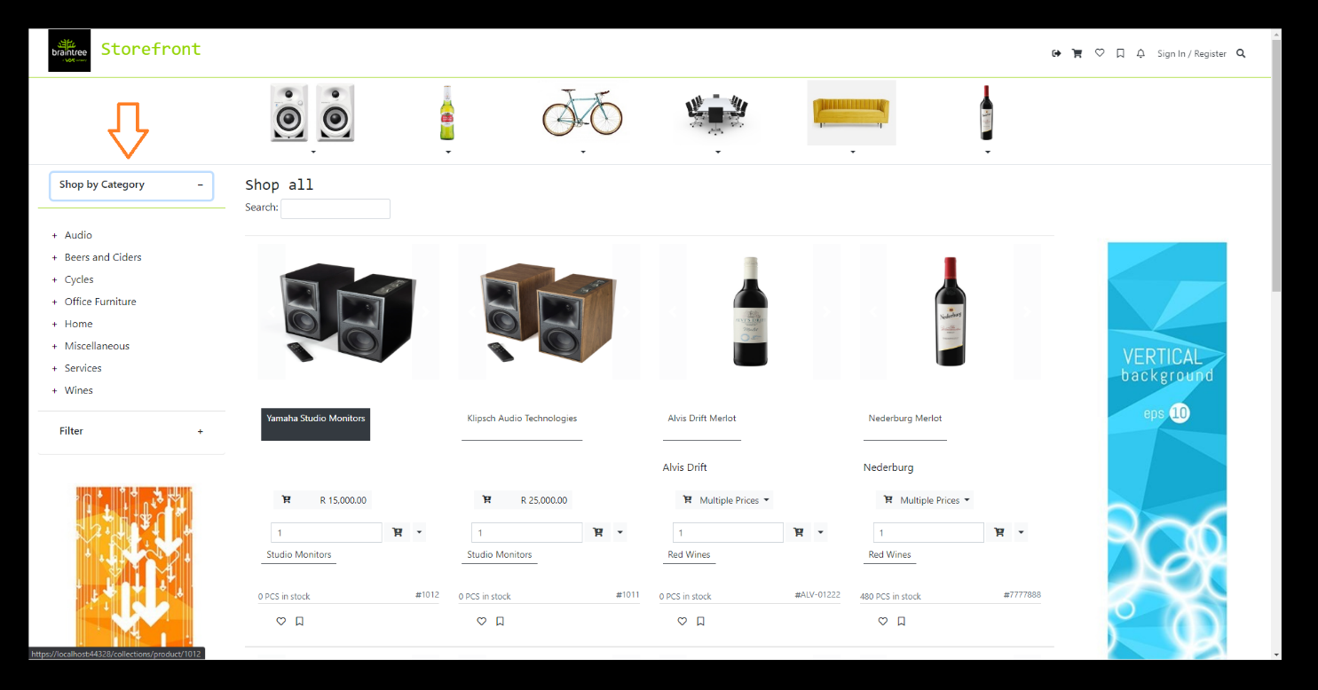

Search & navigate to Item Categories:

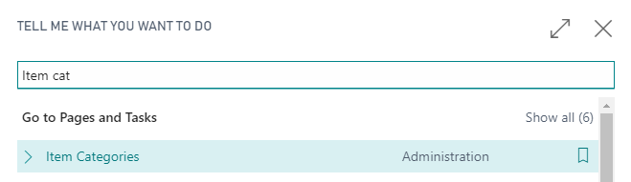

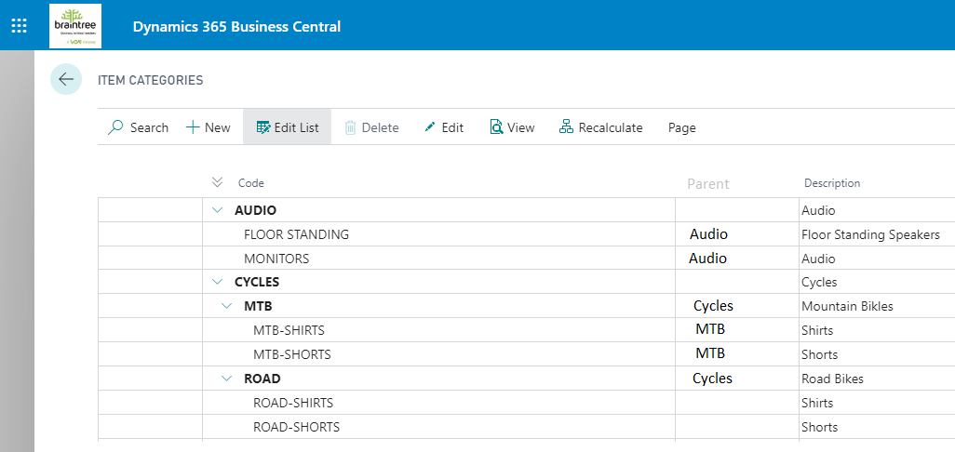

## Create a new Category

Select New to create a new department or top line category: AUDIO

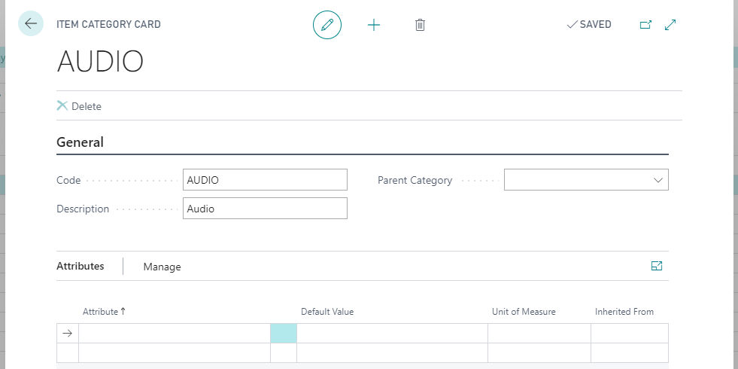

Now create Floor Standing Speakers as a child category for AUDIO.

We will also apply Attributes to it, Brand Yamaha. Attributes are any product category characteristics which your customers may want to search for, such as height and model year:

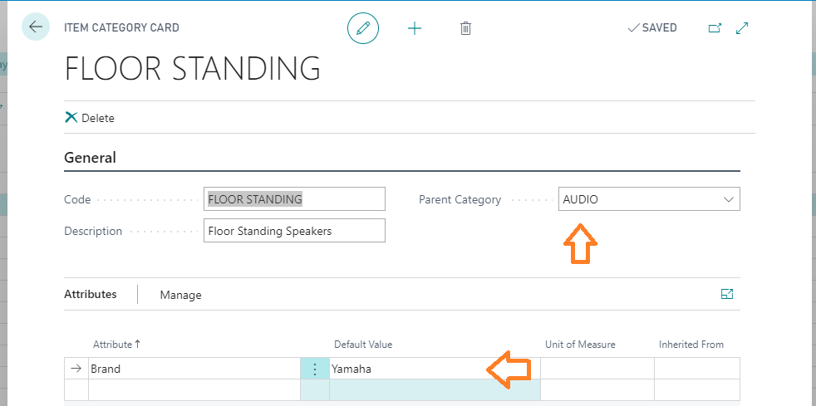

Ecommerce Brand attribute filters:

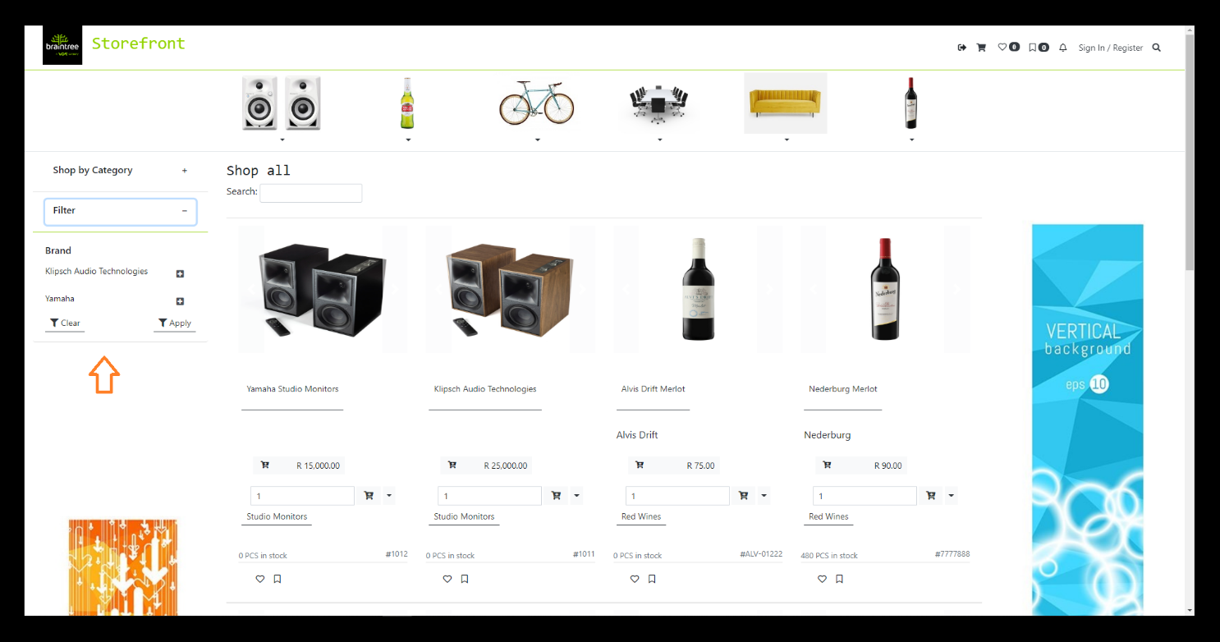

## Promote a Category

Promoted categories are displayed in the promoted menu bar, just below the Ecommerce menu bar:

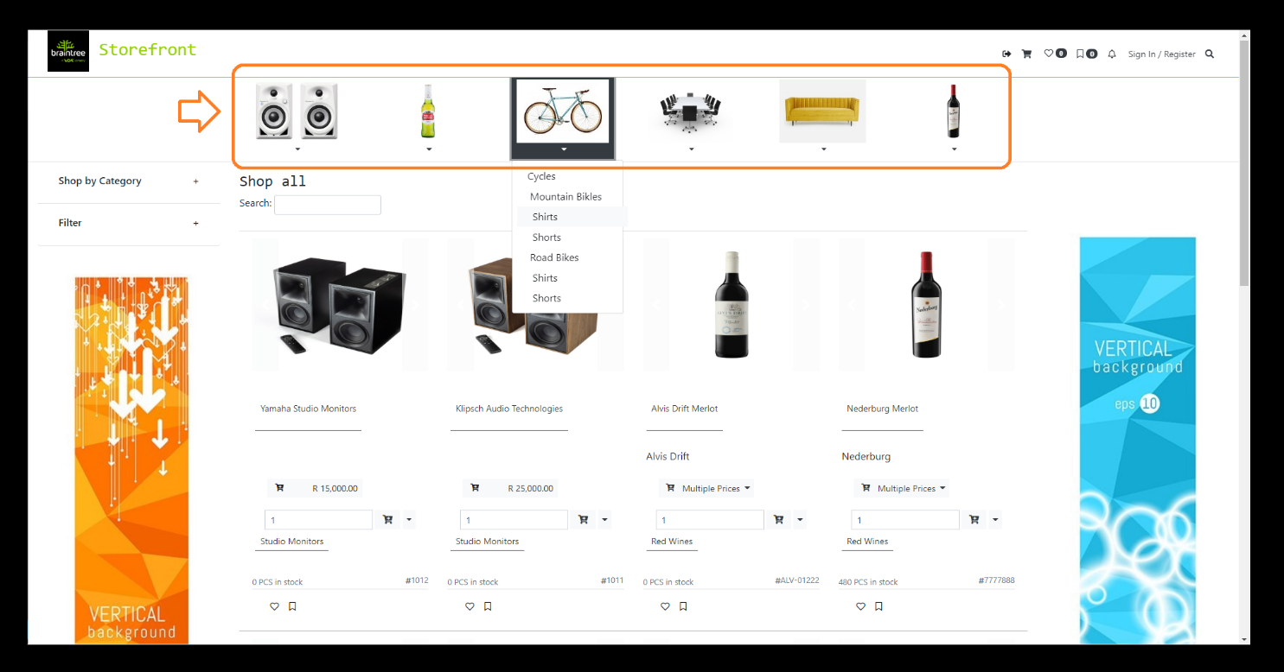

Change your role to Storefront

Select Storefront Setup, then Storefront Setup to edit promoted categories:

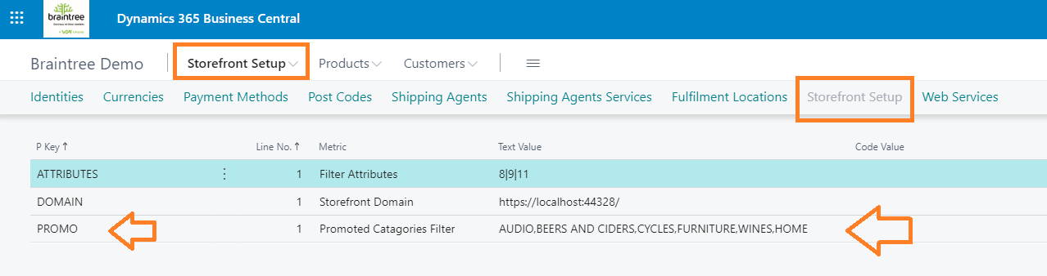

Create or edit the PROMO line to list promoted categories:

* Item Category Codes [as per the Item Categories list] should be used, separated by a comma
* No extra spacing or characters are allowed.
* Example:

P Key: PROMO

Text Value: AUDIO,CYCLES,FURNITURE,HOME AND GARDEN

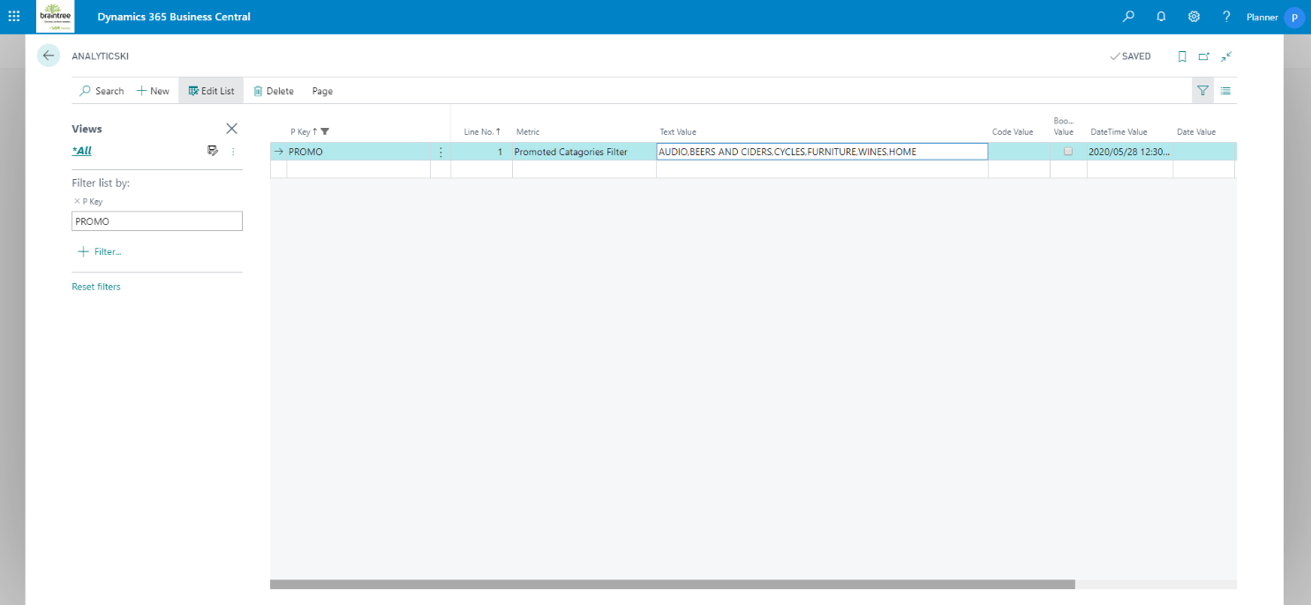

# List a Product

## Create an Item

Assumes Business Manager Role

Create Items to represent your Ecommerce products. Search & navigate to Items:

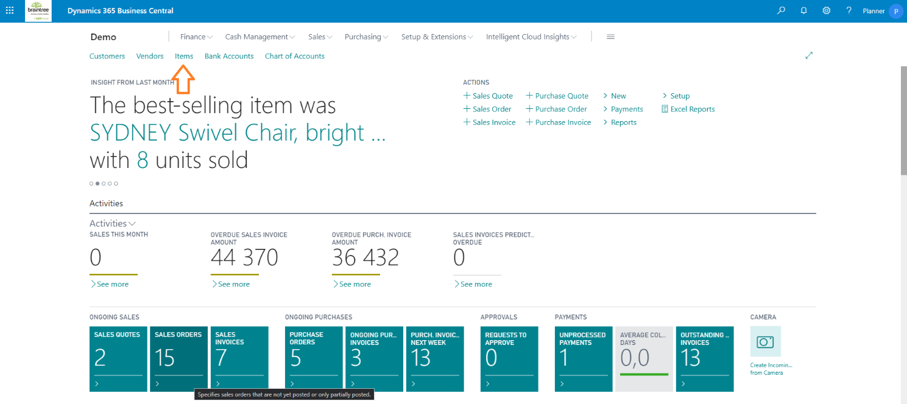

Select New and then an appropriate template for your new product:

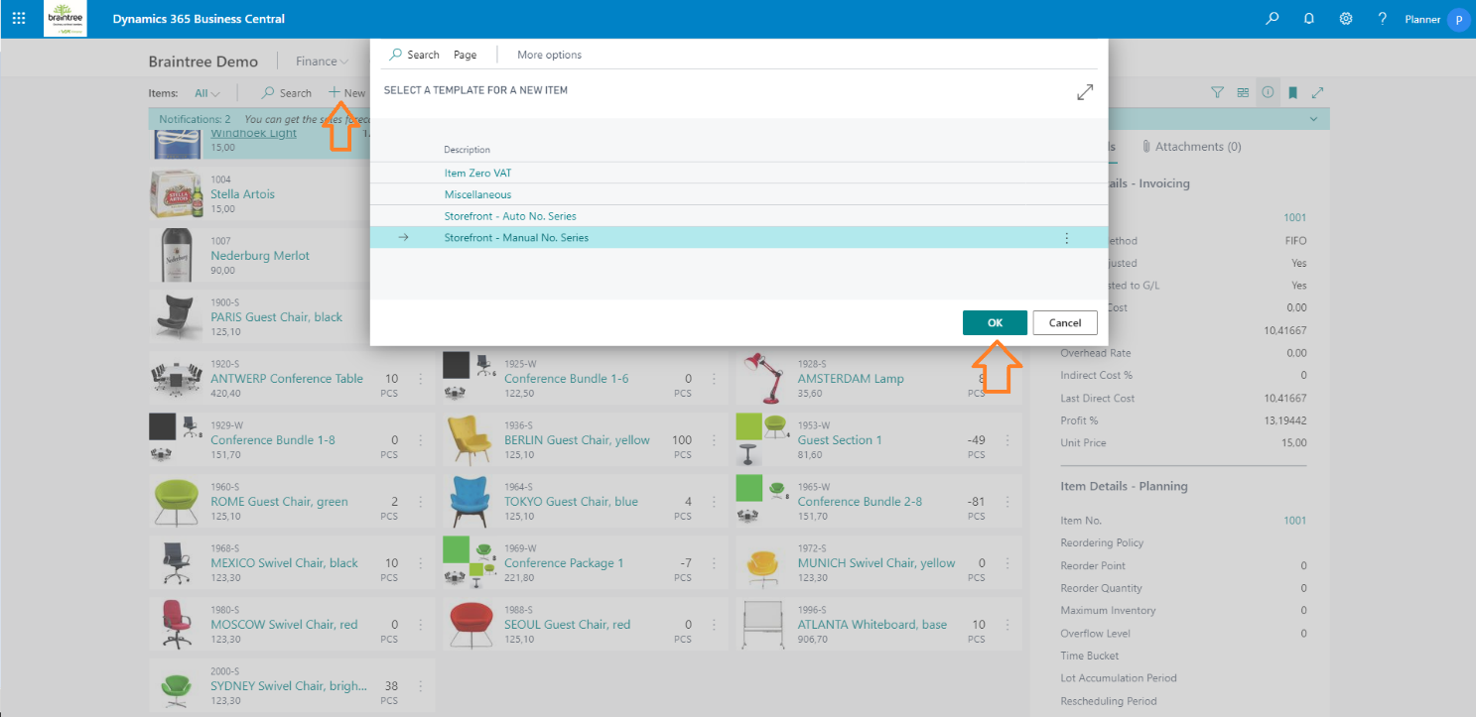

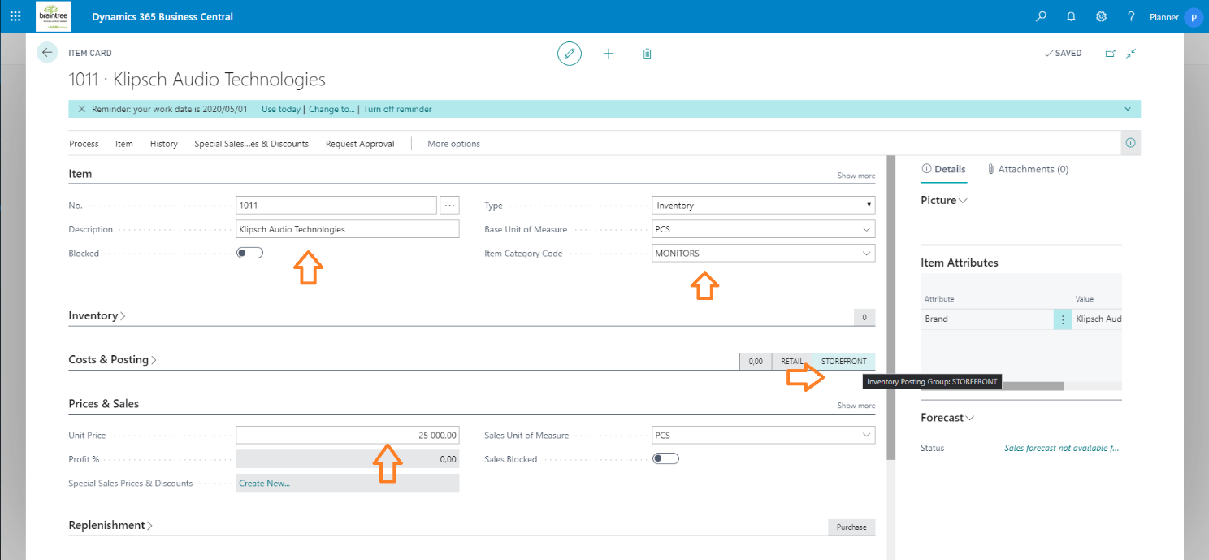

Make sure to specify:

* Description Tip: Ecommerce Product search is powered by this field. Include to make things easier to find.
* Base Unit of Measure
* Item Category Code
* Inventory Posting Group: STOREFRONT
* Unit Price
* Picture is optional

## Special Pricing

From the Item Card, select Special Sales Prices > Set Special Prices to specify special prices:

* Quantity breaks
* Different Units of Measure
* Date specific

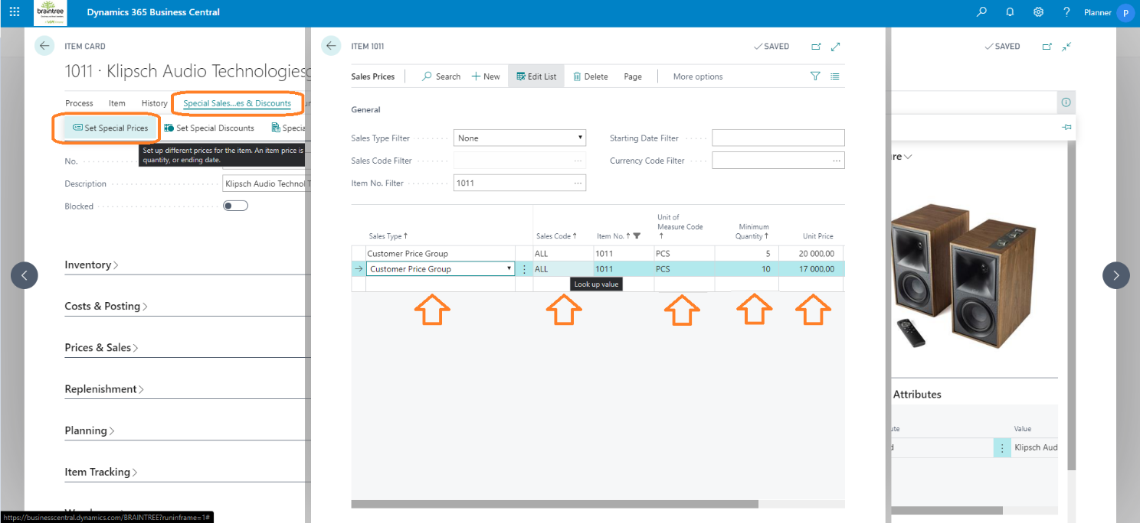

## Delist a product

Block or Sales Block the Item Card to delist a product.

## Bulk Creation

Bulk import Special Prices: Search & navigate to Configuration Packages:

* Find RapidStart Configuration Package: **STOREFRONT PRICES**

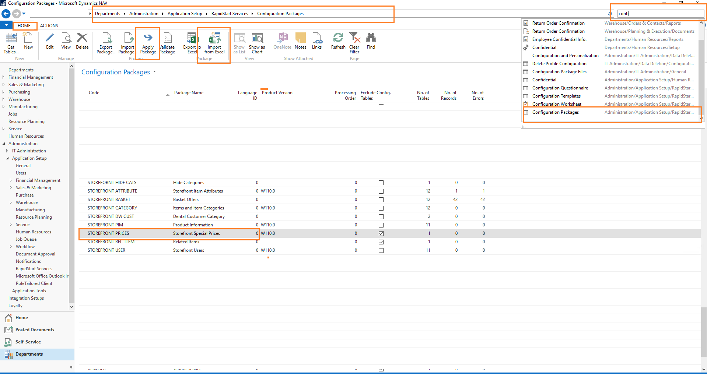

* HOME (Navigation Bar) > Import from Excel > Select a new Price file.
* HOME (Navigation Bar) > Apply Package
* Open Card and check for import errors:
* HOME (Navigation Bar) > Edit
  + Config. Package Card:

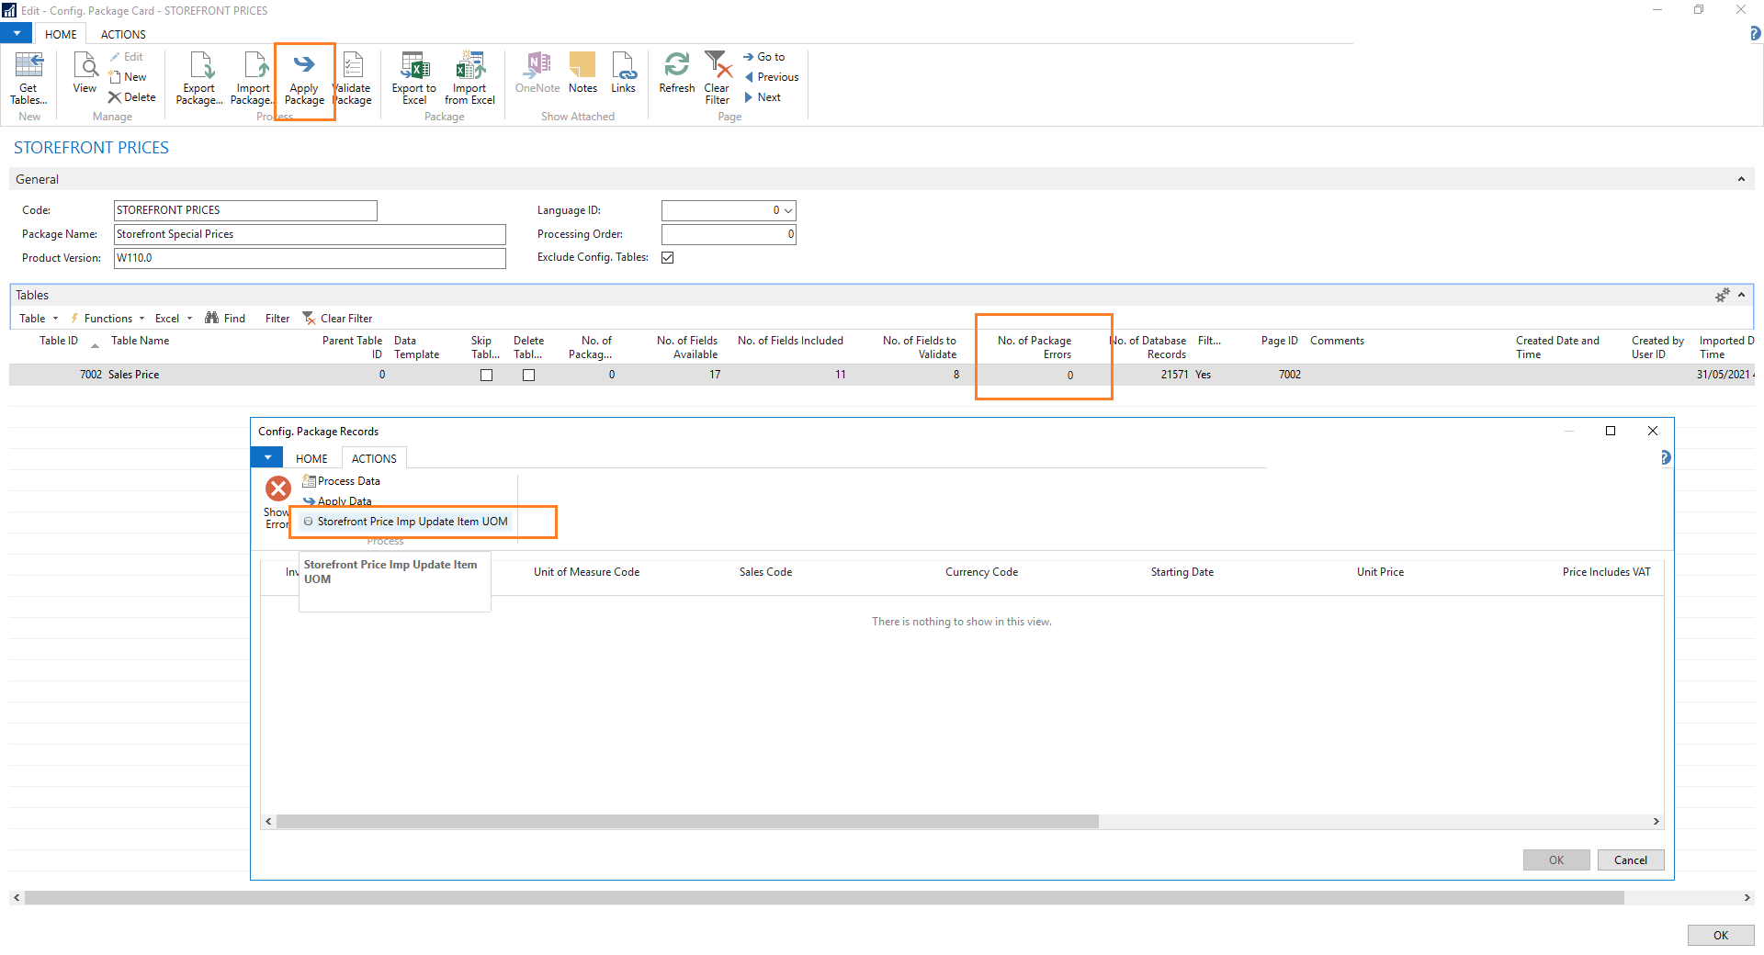

* On the lines > Drilldown on No. of Package Errors, if any – normally related to incorrect units of measures.
* Select ACTIONS (Navigation Bar) > Storefornt Price Imp. Update Item UOM
* HOME (Navigation Bar) > Apply Package

Import File Format:



To import, create & update products in bulk, contact us at [braintree.support@voxtelecom.co.za](mailto:braintree.support@voxtelecom.co.za).

## Product Information Management

* Rapid Start Configuration Package: STOREFRONT REL. ITEM
  + STOREFRONT PIM
  + STOREFRONT PIM-SHORT
  + Don’t specify a Line No for new entries.

## Related Products / Variants

* Rapid Start Configuration Package: STOREFRONT REL. ITEM
  + Don’t specify a Line No for new entries.
  + Metric: type of item relation: variant or related or alternative (Case sensitive)

# Create a Customer

Assumes Business Manager Role

Create Customers to represent your Ecommerce customer accounts. Customers can also register online.

Search & navigate to Customers:

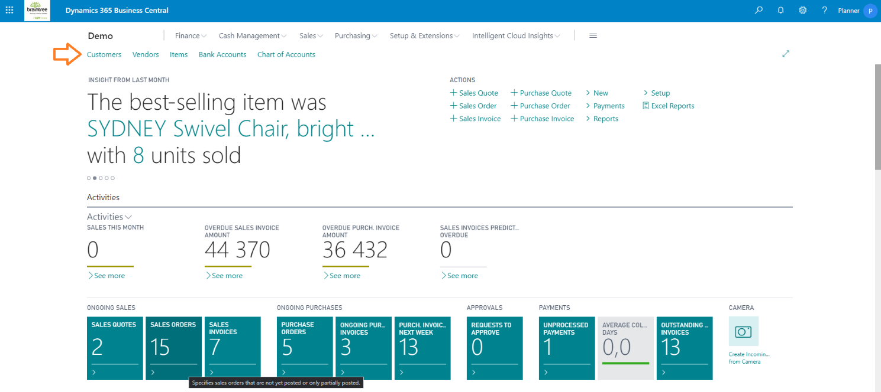

Select New and then an appropriate template for your new customer account:

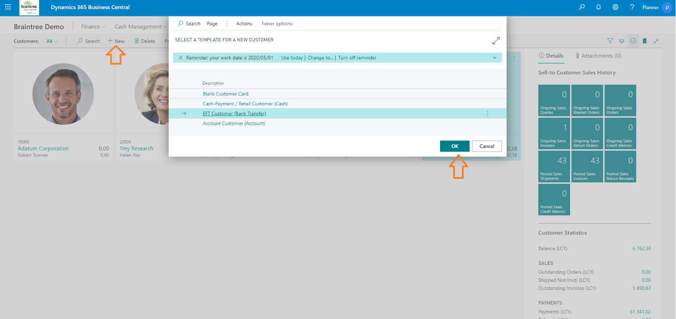

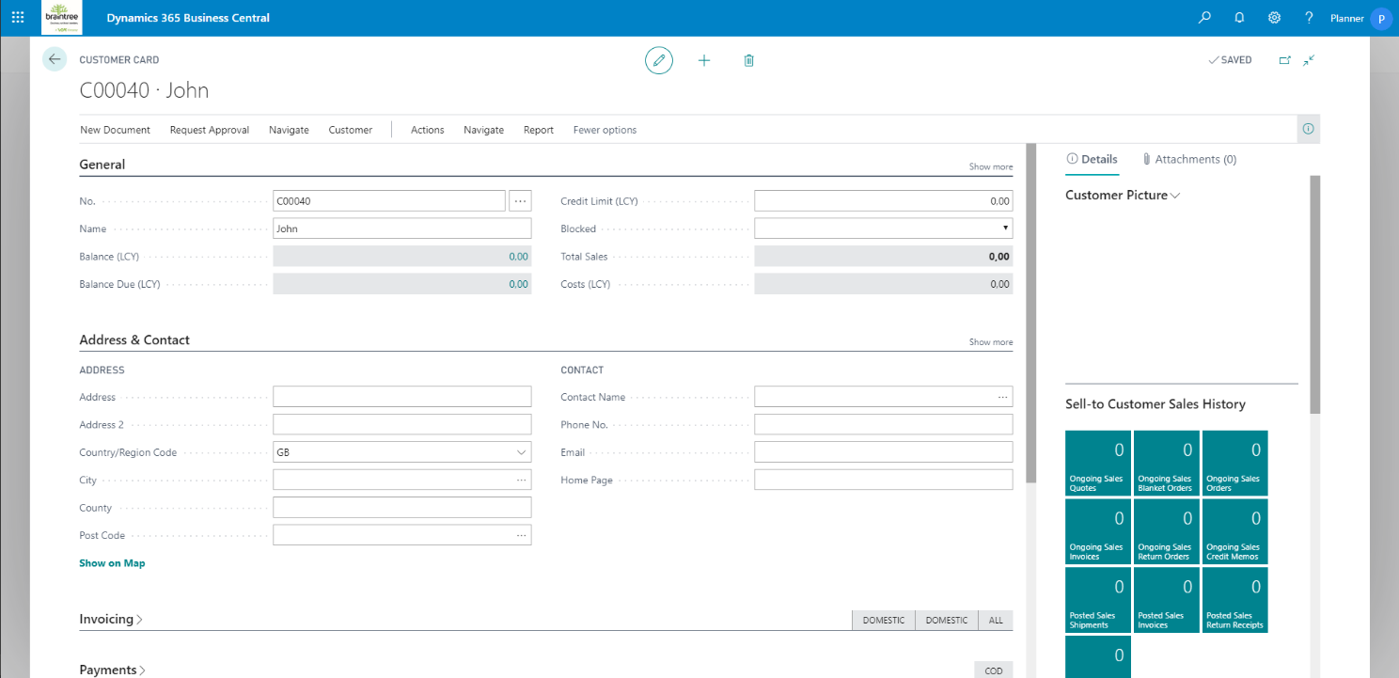

Make sure to specify:

* Name
* Credit Limit (LCY), set to zero for cash customers.
* Address & Contact information
* Payment Method
* Customer Price Group: ALL
* Set Blocked to All to prevent a customer from placing new orders.

## Default Payment Methods

Search & navigate to Payment Methods:

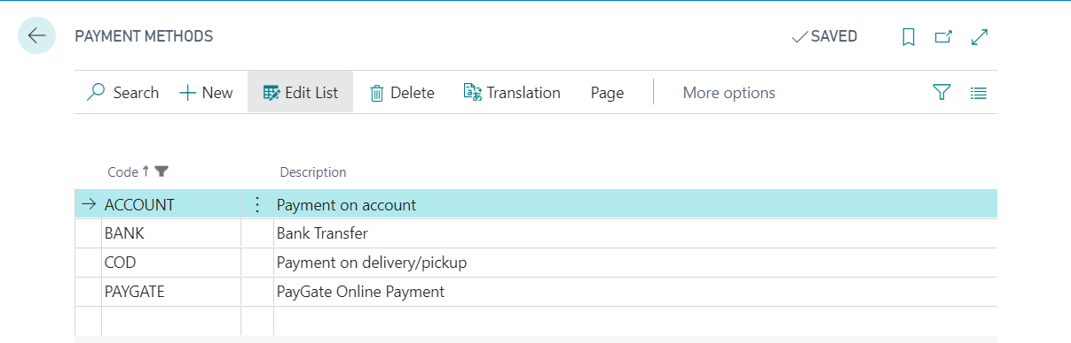

These payment methods are preconfigured as available in the Shopping Cart. Delete a payment method to remove it as an available payment option.

To enable a new Payment Method workflow on Ecommerce, contact us at [braintree.support@voxtelecom.co.za](mailto:braintree.support@voxtelecom.co.za).

# Create an Ecommerce Login Account

Assumes Business Manager Role

Create Storefront users to represent your Ecommerce login accounts. Customer accounts are linked to logins. Customers can also register online.

Register on the website.

Search & navigate to Storefront Users:

Select for new logins created, and allocated to an account, if required:

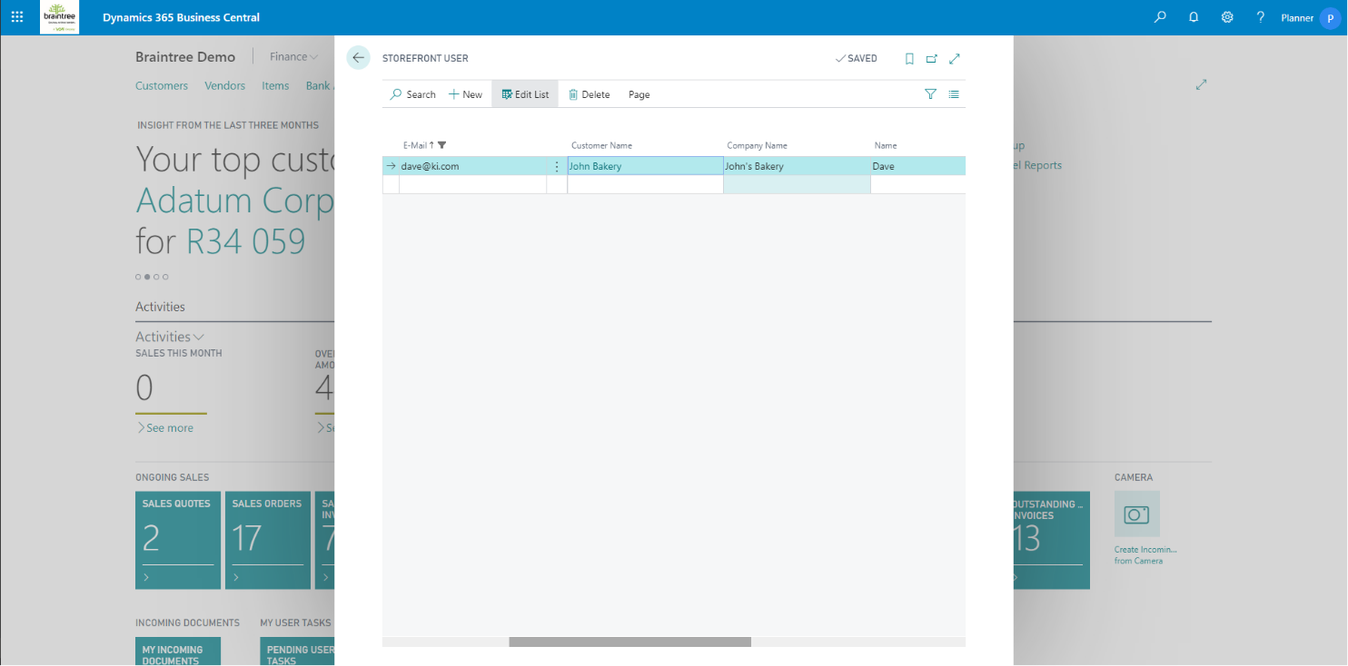

Make sure to specify:

* Customer No.: The customer account who the login relates to.

Users can also be created from the Customer Card/List and Salesperson List Create Login Action.

### Disable a Login Account

Select the login account you want to disable, then Delete.

### Password Reset

Select the login account you want to reset, then enter a new password in the Password field. User password reset requests are marked as Password Reset Requested

Reset Password: Creates a new random password for the selected. Email is also sent with the password reset steps.

Reset Password (Account No as Psw): does not send an email. Make use of the Reset Password option instead.

# Order Processing

Assumes Business Manager Role

Search & navigate to Sales Orders:

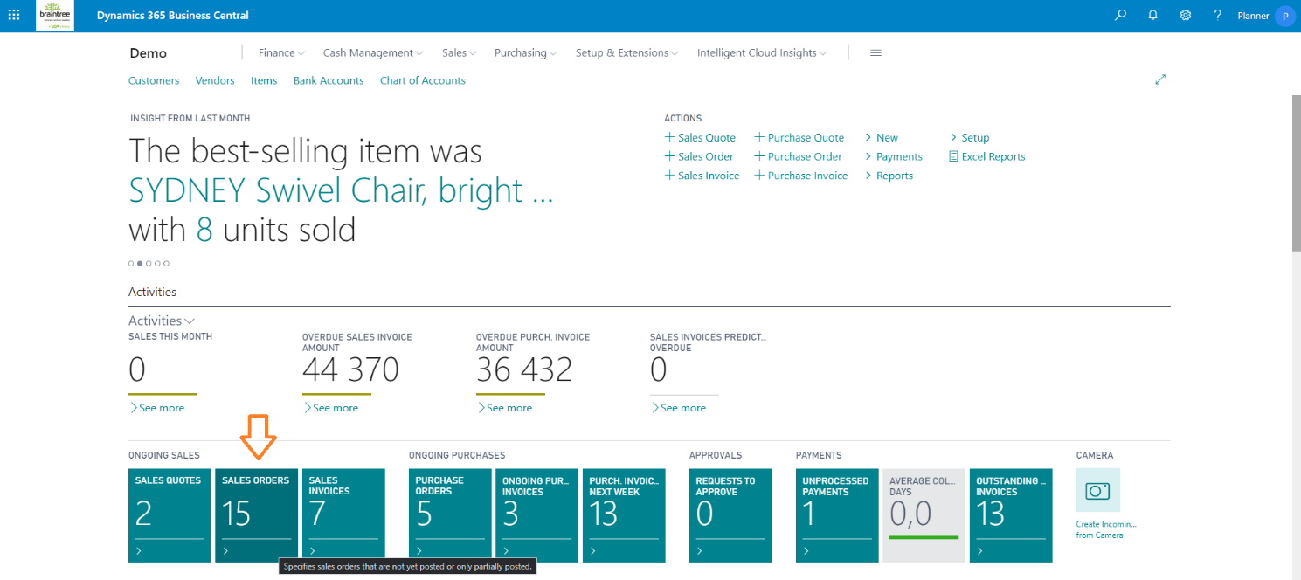

The Sales Orders list show all recent orders and associated Cart and Fulfilment Statuses. Select Manage to edit or view order details.

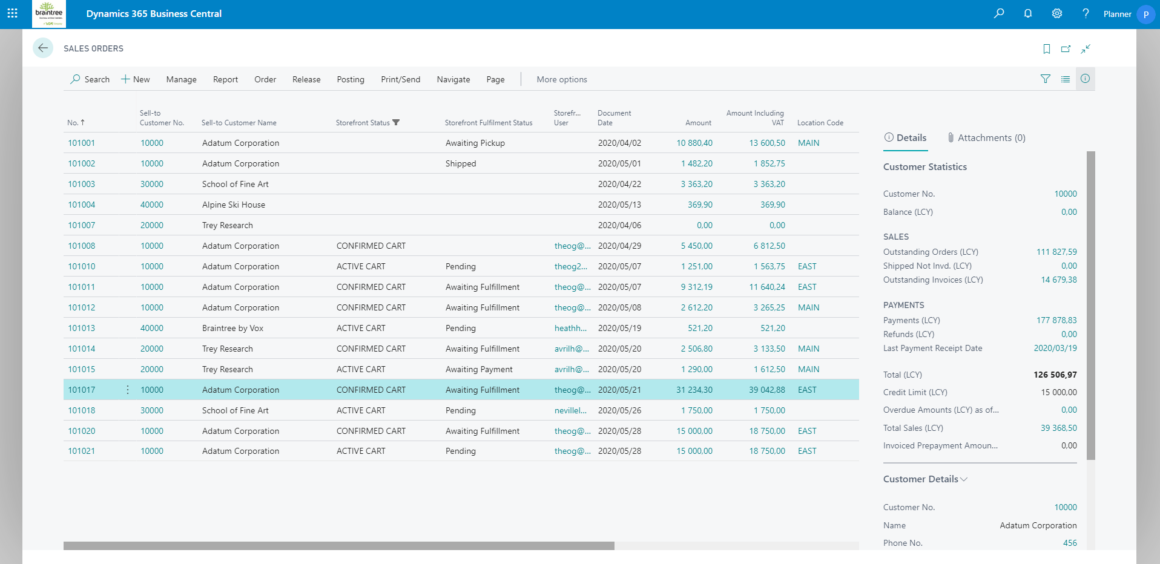

## Send an Order Confirmation

Select an Order, then Print/Send, to print or e-mail an order confirmation:

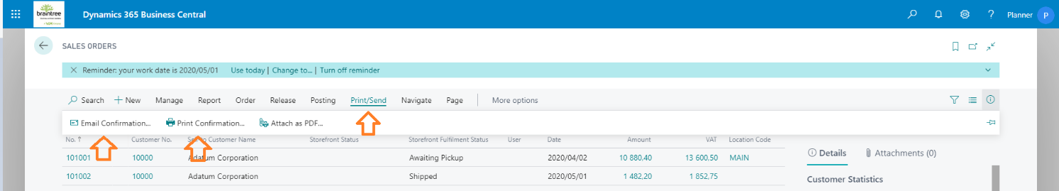

## Process an Order

Select an Order, then Posting and Post & Send, to process an order:

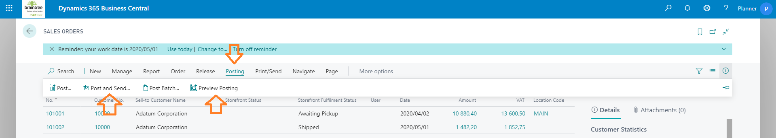

Tip: Use Preview Posting to review your order first.

Select Ship and Invoice to process the entire order:

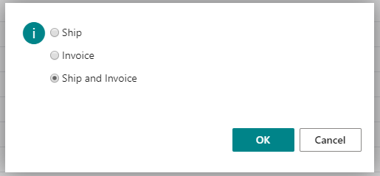

Select Yes to print or download a Shipment Manifest:

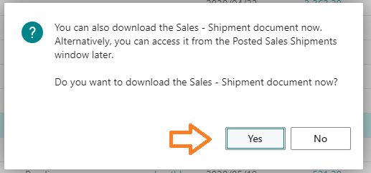

Invoice and Shipment Document Templates:

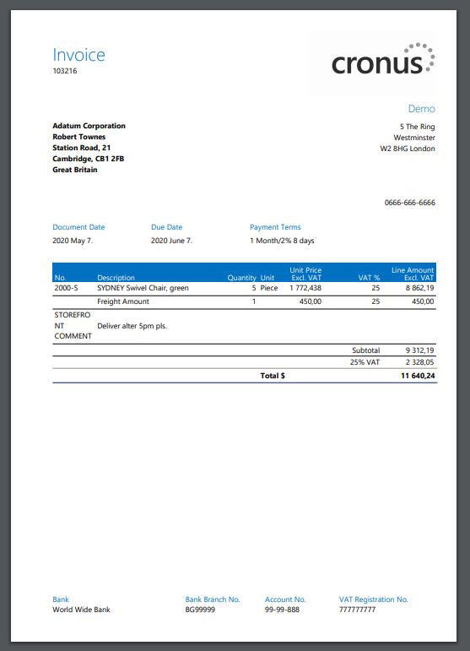

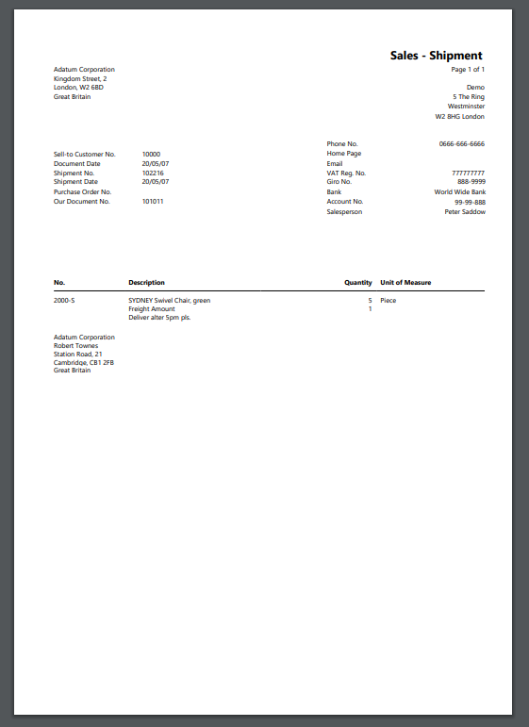

A built-in Microsoft Word report designer is available to change report & document layouts.

## Process a Payment

Search & navigate to Customers. Select or view the Customer Card. Select Actions, then Post Cash Receipts:

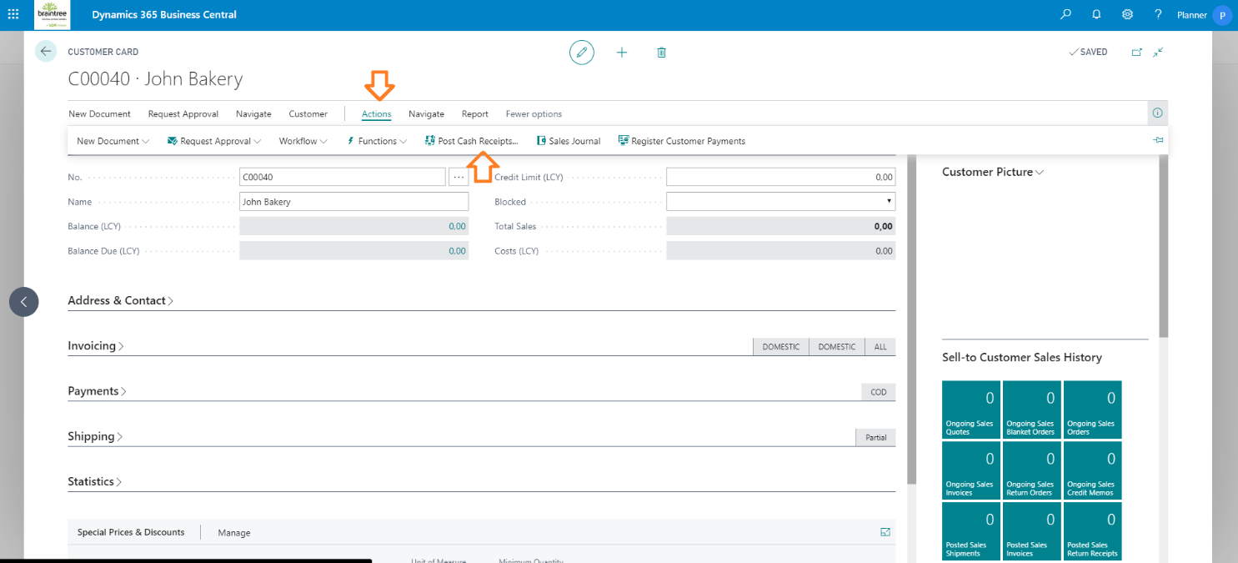

Capture a customer payment:

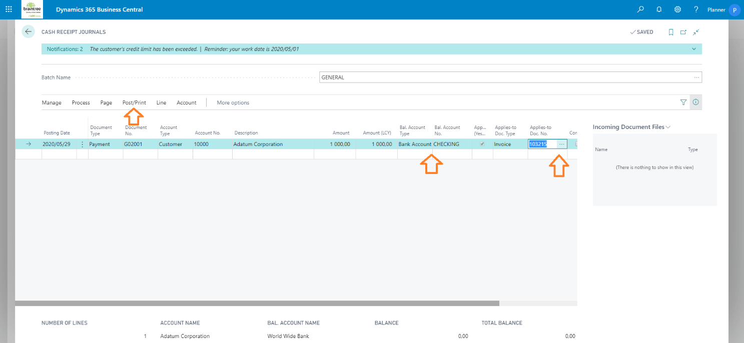

Make sure to specify:

* Posting Date for the payment date
* Document Type: Payment
* Account Type: Customer
* Account No.: The customer’s No. you want to pay
* Amount. Amount & Amount (LCY) should be the same for payments in your local currency.
* Bal. Account: Bank
* Bal. Account No.: Your Bank Account Card
* Applies to Doc. Type: Invoice
* Applies-to Doc. No.: Drilldown to select the order invoice that the payment applies to:

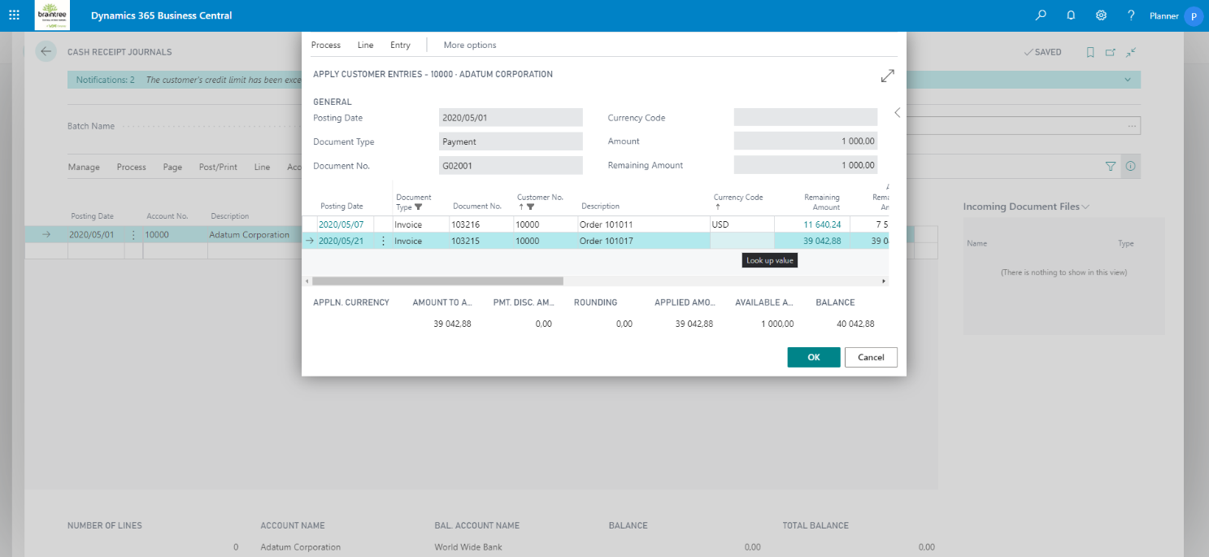

Finally process the payment by selecting Post/Print, and Post and Print

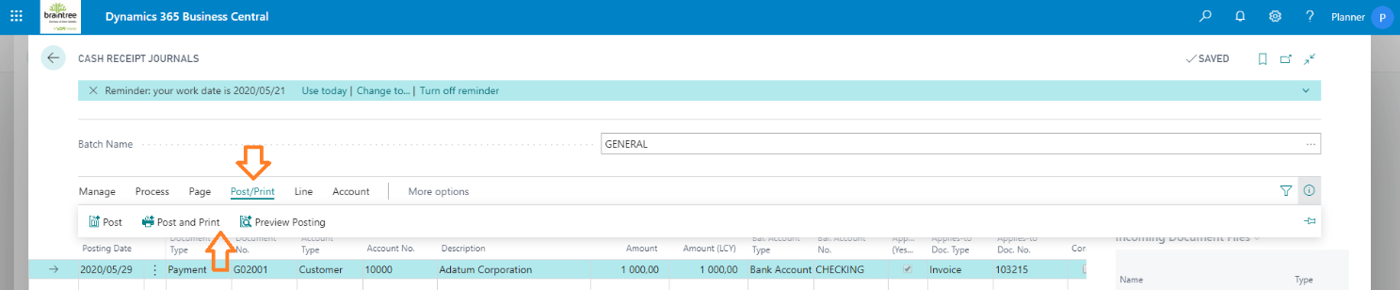

Tip: Use Preview Posting to review posting first.

## Process a Return

Search & navigate to Sales Return Orders.

Select New to create a new return.

Select the Customer Name field, and then to copy a processed order invoice to return; select Actions > Functions > Copy Document:

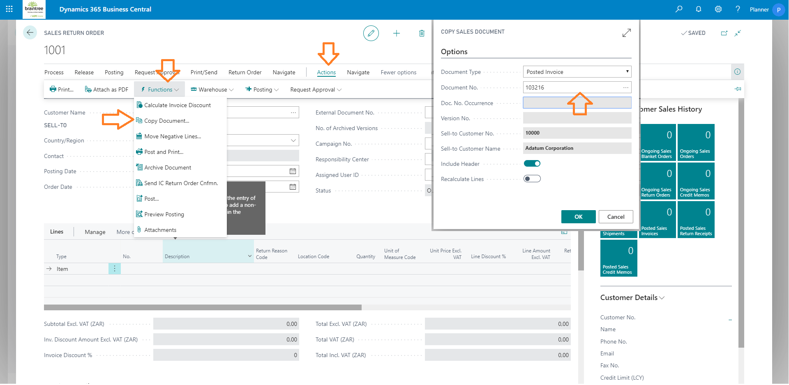

Edit the return if necessary, finally select Posting then Post and Print to complete the return order:

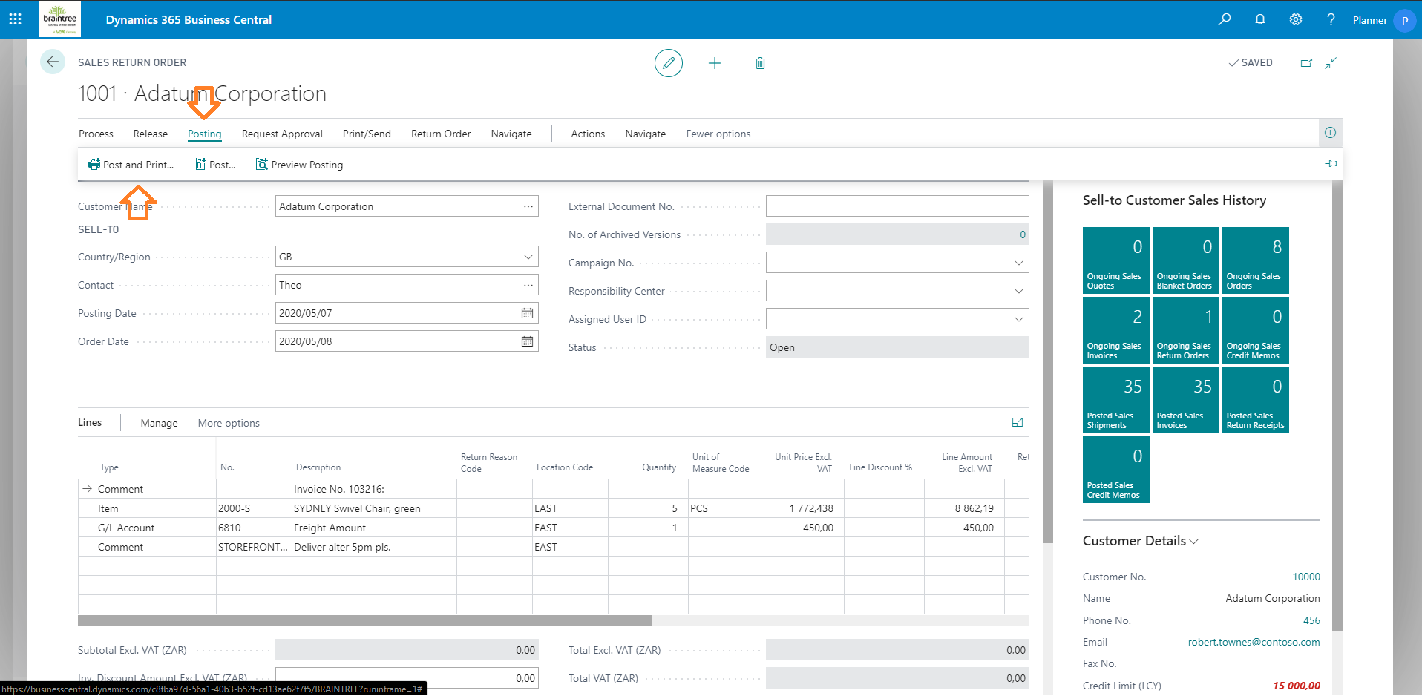

Tip: Use Preview Posting to review your order first.

# Content Management

## Self Service

Users configured as Web Admin, Storefront Identities > Type, will notice a new button available wherever content can be edited:

The following content can be edited:

* Logo
* Left and Right Banners
* Left and Right Banners for Customer Price Groups, configured from the Account Page
* Items/Products, configured from the Product Page
* Item/Product Information and Data Sheets, configured from the Product Page
* Items/Product Categories, configured from the Category Page

Supported content:

* Images
* Videos
* Files

Multiple files can be uploaded at the same time.

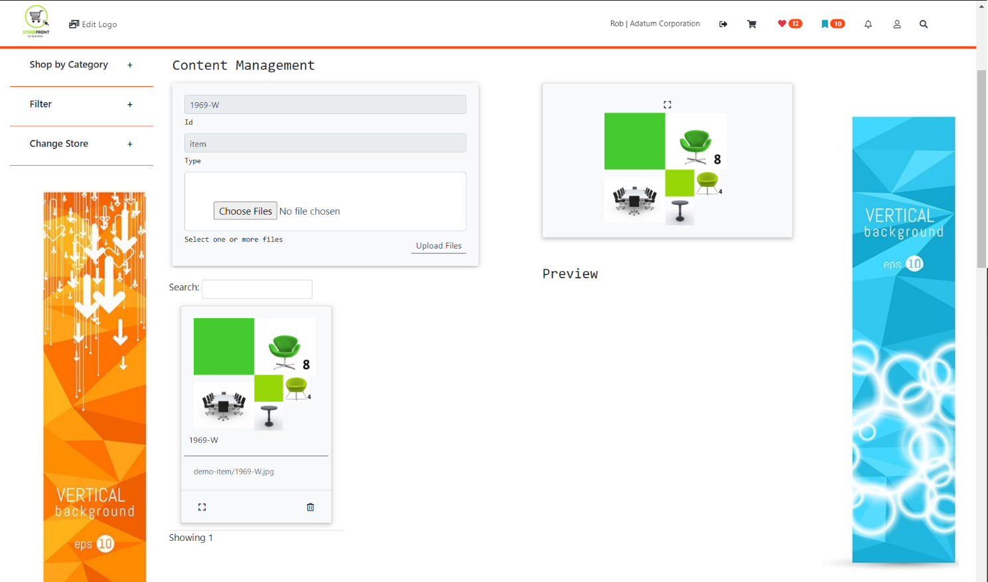

## Static Content – basic CMS

Create a new folder and subfolders on OneDrive as follows:

* Storefront Content
  + banner
  + category
  + home
  + product

Keep these folders up to date with your published products, promoted categories and banners. Ecommerce content updates are applied periodically. Contact us at [braintree.support@voxtelecom.co.za](mailto:braintree.support@voxtelecom.co.za) to schedule a deployment slot.

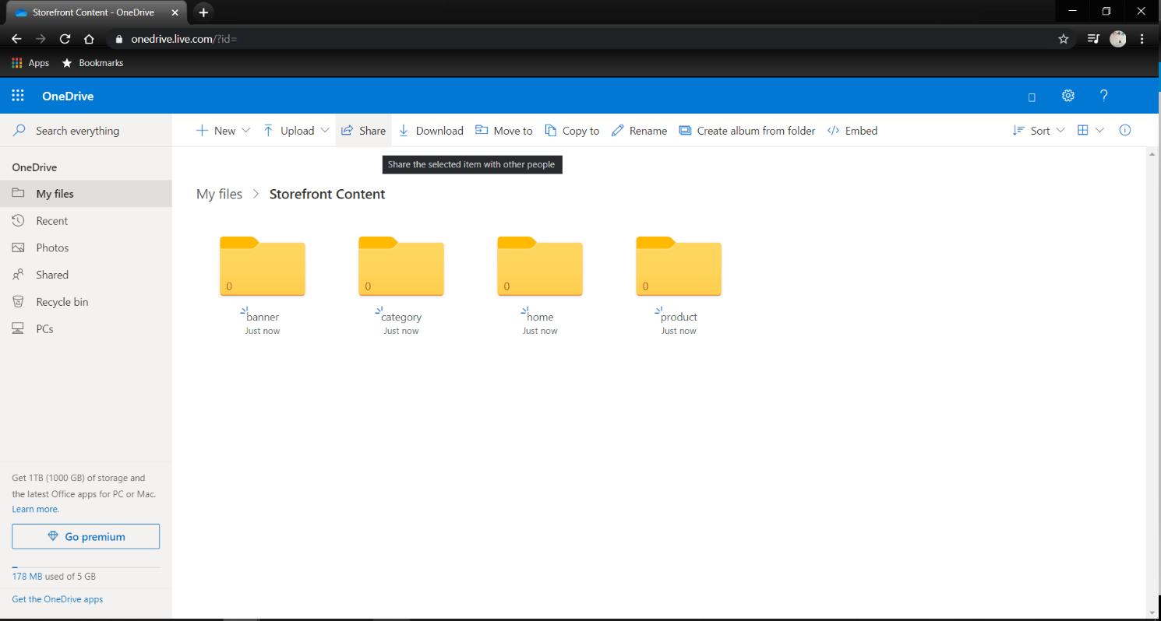

Free sign-up here: <https://www.microsoft.com/en-za/microsoft-365/onedrive/compare-onedrive-plans>

Content file names & naming conventions:

* Banners:

banner-left.jpg

banner-right.jpg

* Category:

<Item Category Code>.jpg

AUDIO.jpg

HOME AUDIO.jpg

* Product:

<Item No.>.jpg

<Item No.>-<Image No>.jpg

1000.jpg

1000-1.jpg

1000-2.jpg

Image file types must be universal for all product content. Default type: jpg.

* Home:

splash.jpg

main-1.png

main-2.png

main-3.png

mobile-1.png

mobile-2.png

mobile-3.png

# Payment Service Provider Integration

## Online Payments

Payments received online reflect against the Sales Order > Storefront fast tab or Actions > Storefront Payments.

To process these into the General Ledger, Bank and Customer sub ledgers:

* Create a new General Journal Batch for the Cash Receipts Journal Template:
  + Journal Template Name: CASHRCPT
  + Journal Batch Name: ONLINEPMTS
  + Balancing Account Type: Bank
  + Balancing Account No.: relevant Bank.
* Configure a Job Queue to automatically create a journal for payment received. These journal lines can be posted when convenient:
  + Search & navigate to Job Queue Entries
  + Select New
  + Object Type to Run: Codeunit
  + Object ID: 73501
  + Next Run Date Formula: 1D to run once a day

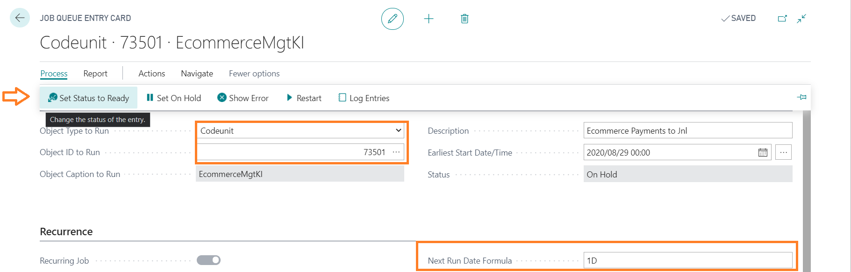

## PayGate

We need the following information from you to enable PayGate as a Payment Service Provider:

* PayGate ID
* PayGate Secret

## Netcash – Pay Now

We need the following information from you to enable PayGate as a Payment Service Provider:

* Pay Now Service Key

# Tips

## Naming conventions and standards

Item/Product Codes and Item Category Codes should not contain any special characters or spaces.

## Create a Ecommerce Test Account

Follow Steps 6 and 7 to create a Customer Card and Login for a Test Account.

## Set up E-mail notifications

E-mail notifications are used to notify ecommerce users of order fulfilment status updates. E-Mail notifications are also required to assist & automate password reset requests.

Search & navigate to SMTP Mail Setup:

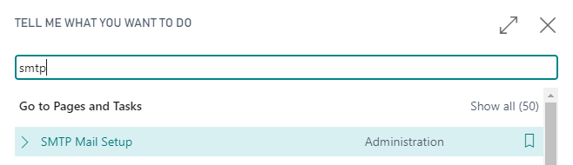

Configure your e-mail account for notifications:

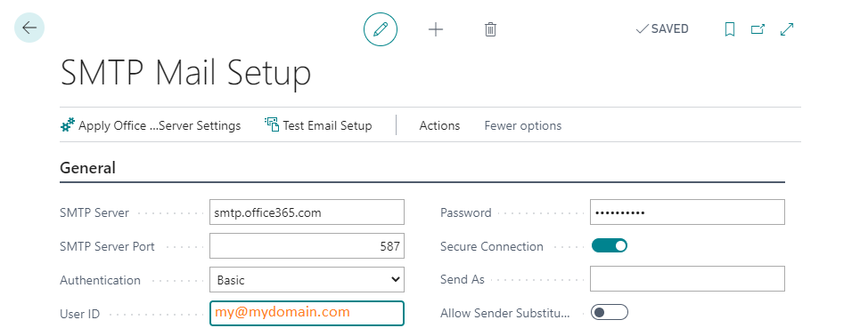

Make sure to use the Test Email Setup option to ensure everything works as expected.

Change your role to Storefront

Select Storefront Setup, then Storefront Setup to configure your ecommerce domain information:

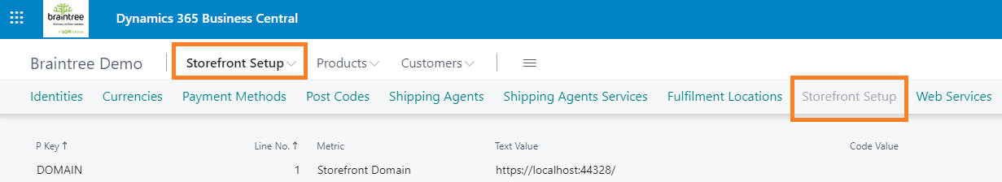

Create or edit the DOMAIN line to specify your ecommerce website url:

* Example:

P Key: DOMAIN

Text Value: http://my-ecommerce-store.com/

## Email Events

* BC SF User > Reset Password
* BC Sales Order > Updates to the Fulfilment Status
* User website self service
* Cart confirmations (Storefront Status)
  + CONFIRMED CART (Account orders)
  + PAID CART (Paid online)
  + CONFIRMED QUOTE (Quote requested)
* Account > Email Document: Order, Quote, Invoice
* Forgot Password

## Add a Click & Collect Location

Change your role to Storefront:

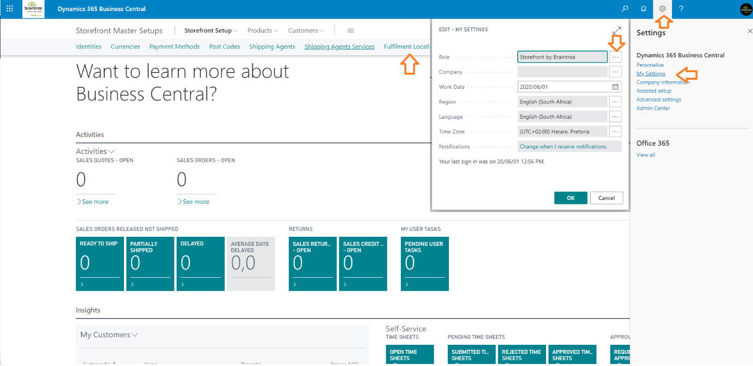

Select Storefront Setup, then Fulfilment Locations to edit locations:

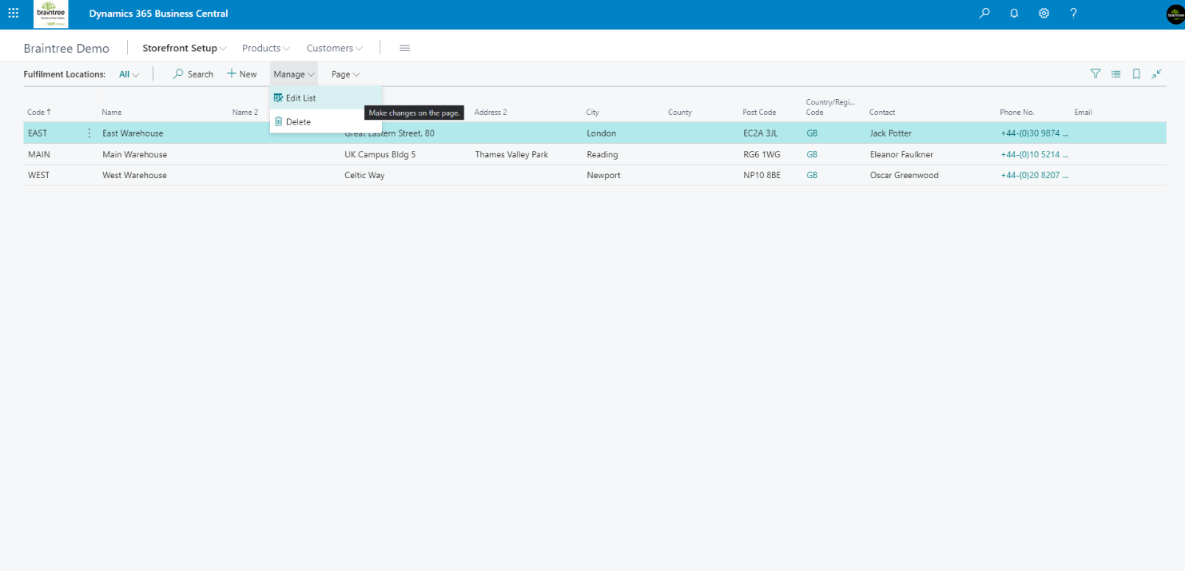

## Add a Customer Delivery Address

Assumes Business Manager Role

Search & navigate to Customers.

Select the appropriate customer, then More options > Actions > Navigate > Customer > Ship-to Addresses:

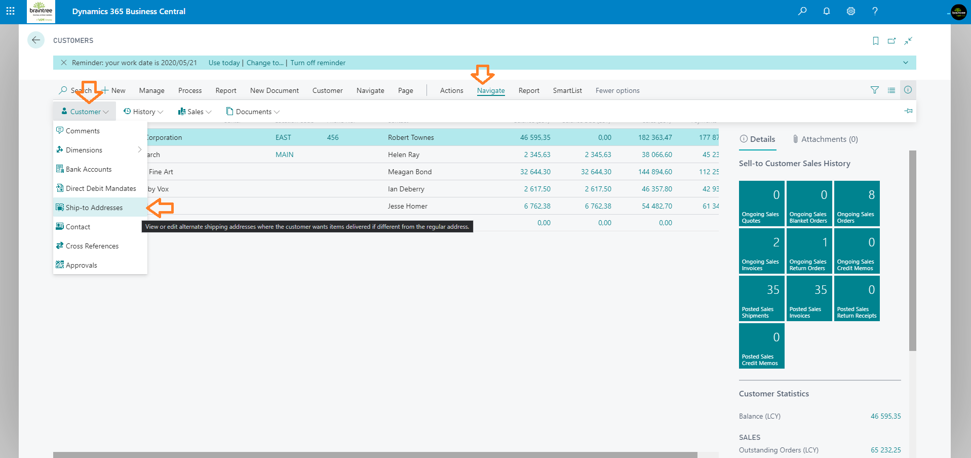

Edit the customer’s Ship-to Addresses:

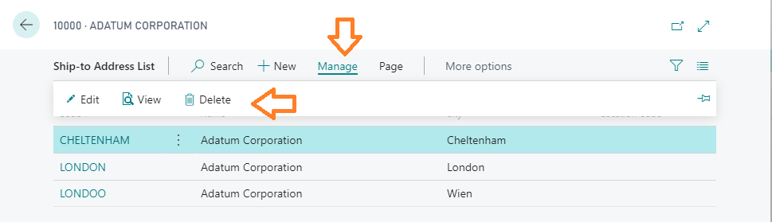

## Add a Shipping Provider & Charge

Change your role to Storefront:

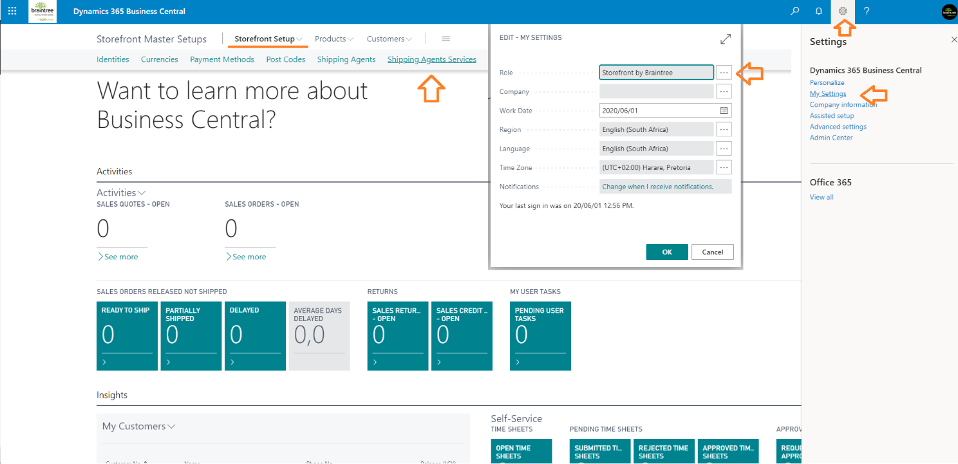

Search & navigate to Sales & Receivables Setup.

Specify your Shipping Services G/L Account as the Freight G/L Account No.:

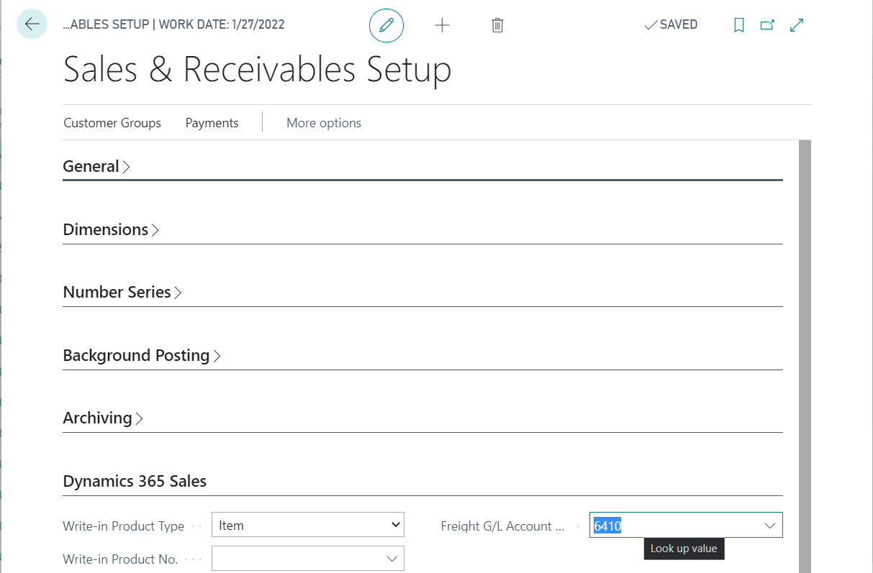

Select Storefront Setup, then Shipping Agents to edit providers or Shipping Agent Services to edit services.

Remember to specify shipping lead times and associated costs:

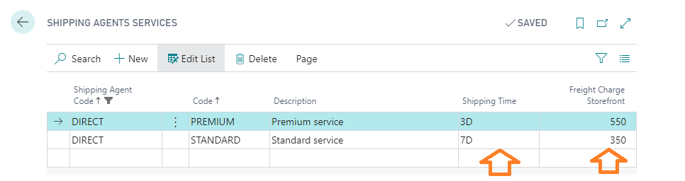

## Setup

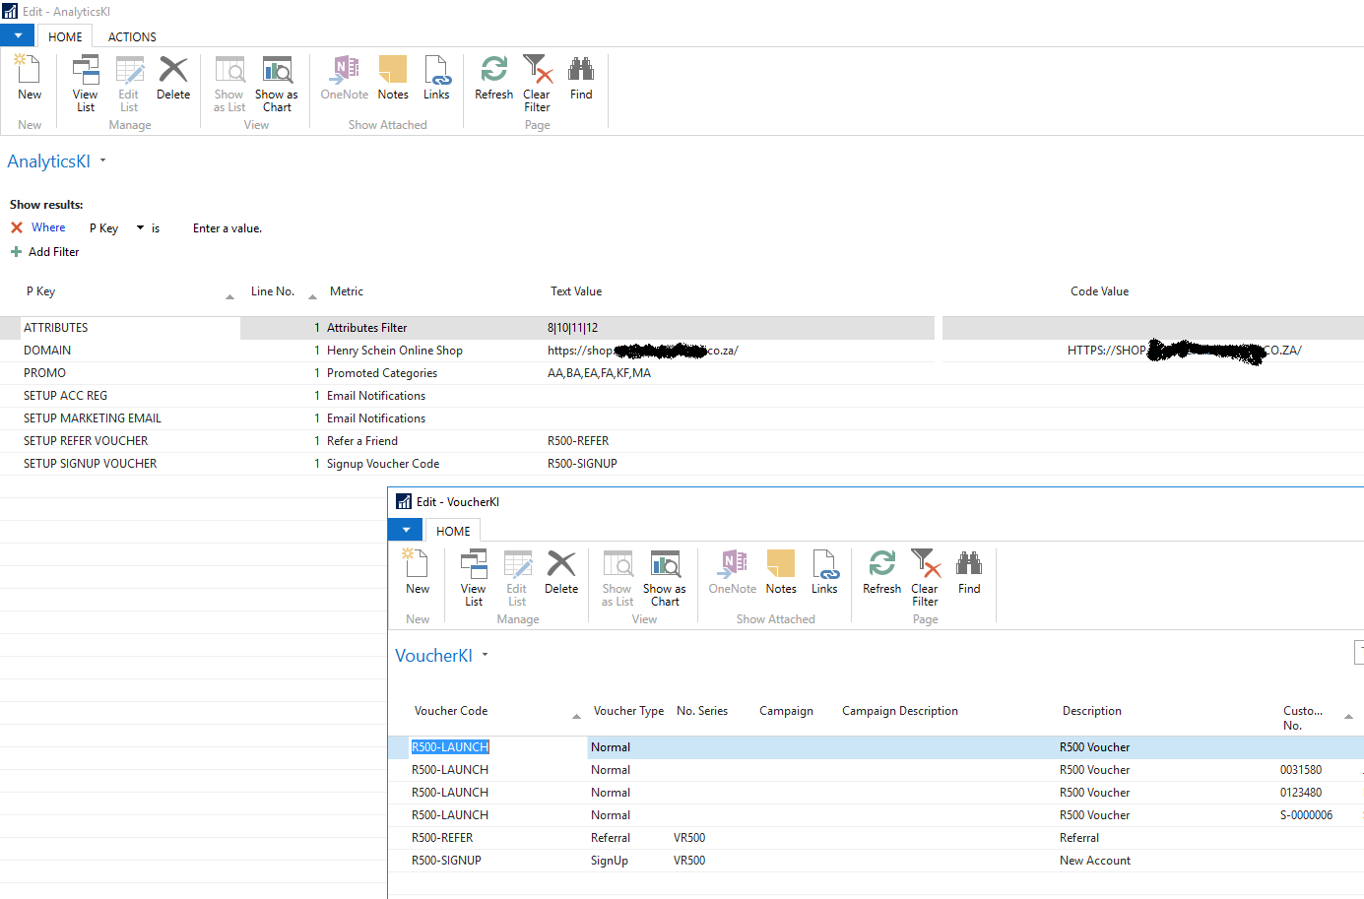

## Cart & Order Statuses

|  |  |  |  |
| --- | --- | --- | --- |
| **User** | **Storefront Status** | **Fulfilment Status** | **Comment** |
| Add a product to create a new cart | ACTIVE CART | Pending |  |
| Confirm the Cart | CONFIRMED CART | Await Payment | Implies “To Account”, if not paid online |
| Proceed to pay online | PAID CART | Awaiting Fulfilment |  |

# System Requirements

Supported browsers:

* Microsoft Edge 84.0
* Google Chrome 77.0
* Mozilla Firefox 69.0
* Safari 12.0

# Conclusion

For additional assistance, please contact us at [info@braintree.co.za](mailto:info@braintree.co.za).